

SADAIA COMPANY  
Digital Forensic Report



|  |  |
| --- | --- |
| Student | ID |
| Fatimah Baqer | 219028760 |
| Rahaf Ahmed | 219023195 |
| Maryam Alateeq | 219022438 |

|  |  |
| --- | --- |
| Instructor | Dr. Abdulallh Al-Bo-Ali |

Table of Contents

Table of Figures 2

Address Resolution Protocol (ARP) Spoofing 4

1. Introduction 4

1.1 Summary of case and tasking 4

2. Forensic examination 4

2.1 Tools 4

2.2 Chain of custody 4

2.3 Method of process 5

3. Summary of conclusion reached 15

3.1 Expert opinion regarding findings 16

Password Cracking Attack 17

1. Introduction 17

1.1 Summary of case and tasking 17

2. Forensic examination 17

2.1 Tools 17

2.2 Chain of custody 17

2.3 Method of process 18

3. Summary of conclusion reached 20

3.1 Expert opinion regarding findings 20

Social Engineering Tool Kit 21

1. Introduction 21

1.1 Summary of case and tasking 21

2. Forensic examination 21

2.1 Tools 21

2.2 Chain of custody 21

2.3 Method of process 22

3. Summary of conclusion reached 32

3.1 Expert opinion regarding findings 32

References 33

# Table of Figures

Figure 1 - Creating Virtual Machines 5

Figure 2 - List of Machines 5

Figure 3 - Other Devices Address 5

Figure 4 - Ip Address of The Kali Machine 6

Figure 5 - Windows Machine Ip Address 6

Figure 6 - Editing sysctl.conf File 7

Figure 7- Modify the Code 7

Figure 8 - Wireshark Interface 8

Figure 9 - Ettercap Interface 8

Figure 10 - Launching Wireshark and Ettercap 9

Figure 11 - Choosing the 1st Victims 9

Figure 12 - Choosing the 2nd Victim 10

Figure 13 - Creating Man-in-the-middle Attack 10

Figure 14 - ARP poisoning Window 11

Figure 15 - ARP Traffic from Wireshark - a 11

Figure 16 - ARP Traffic from Wireshark - b 11

Figure 17 - Default Gateway Mac Address Before ARP Spoofing 12

Figure 18 - - Default Gateway Mac Address After ARP Spoofing 12

Figure 19 - ARP Packets in Wireshark 12

Figure 20 - Choosing a Packet to Analyze 13

Figure 21 - Windows Mac Address 13

Figure 22- Destination Packet Address 13

Figure 23- Kali Mac Address 13

Figure 24 - Source Packet Address 13

Figure 25 - Operation Code 13

Figure 26 - Packet Information - a 14

Figure 27 - Packet Information - b 14

Figure 28 - Packet Information - d 14

Figure 29 - Packet Information - c 15

Figure 30 - Source Address of Man-in-the middle 15

Figure 31 – Testing with Ping 15

Figure 32 - Creating passwords file 18

Figure 33 - Crack Mod 18

Figure 34 - Load Password File 19

Figure 35 - Show Cracked Password 19

Figure 36: Root in Terminal 22

Figure 37: Interface of SET 23

Figure 38: Interface of the Web attack 24

Figure 39: Cont... 25

Figure 40: Import web template 25

Figure 41: Gateway(kali) 26

Figure 42: Google template 26

Figure 43: creation of the Email 27

Figure 44: Link the email 28

Figure 45:Email that received 28

Figure 46: Phishing the information by using the Google form Sign in 29

Figure 47:Kali gets the information 29

Figure 48:Show the information 29

Figure 49: show it is not secure 30

Figure 50:cont... 31

Figure 51:cont... 31

# Address Resolution Protocol (ARP) Spoofing

# Introduction

The malicious network attack known as ARP (Address Resolution Protocol) spoofing uses flaws in the ARP protocol to intercept, alter, or reroute network traffic. In-depth knowledge of ARP spoofing assaults, their effects, and practical defenses are the goals of this report. It includes a wide range of topics, such as forensic examination methods, frequently used tools, chain of custody, evidence classification, a summary of findings, and expert views on the findings. This research explores these topics in an effort to provide businesses and people with the information and techniques they need to effectively recognize, stop, and respond to ARP spoofing attacks.

## Summary of case and tasking

Status and mission summary Between 1-6-2023 and 15-6-2023, an attack was detected on one of the devices of the SDAIA company, where employee XX began to analyze the network and start taking preliminary evidence, as she began to interrogate the employee XX2 working on the device that appeared from the attack. Where the defendant said that she did not do that, and after examining her device, it was found that she was only a victim, as someone took advantage of his access to the network and started analyzing the addresses on the network of the SDAIA company and targeting the address of the accused victim.

# Forensic examination

Officer XX conducted all searches, tests and experiments related to the digital version of the computer of the accused victim

## 2.1 Tools

In this investigation, employee XX found that Ettercap was used, a defensive attack in the middle solution for LANs that is free and open source. It can be applied to security auditing and computer network protocol analysis. It works on a variety of Unix-like operating systems, and because the IP address was obtained and used in the attack, another device was used to pretend to be the victim and hide the identity of the primary culprit.

## 2.2 Chain of custody

XX2 left her device unlocked during lunchtime, and one of the employees tried to use it, access the IP address and check if it was her or someone else. As a result, the IP address of the employee XX2 was used, which made the hacker get the opportunity to verify the address and use the employee XX2 as a protection shield and cover his identity.

*All these scenarios have been simulated and the attacker character has been worked on

## 2.3 Method of process

* Creating two virtual machines, one as an attacker (kali Linux) and the other one as a victim(windows).

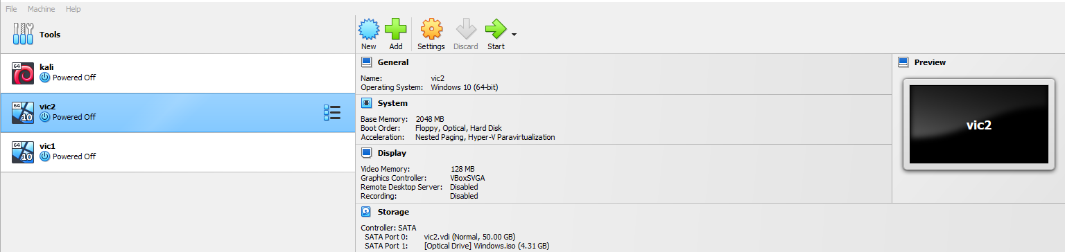

Figure 1 - Creating Virtual Machines

* The below command represents every other machine to the attacker (we have to memorize the last four digits in the mac address because they will change).

Figure 2 - List of Machines

* 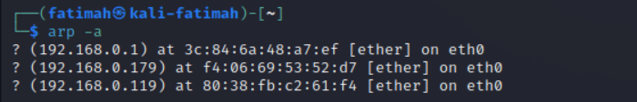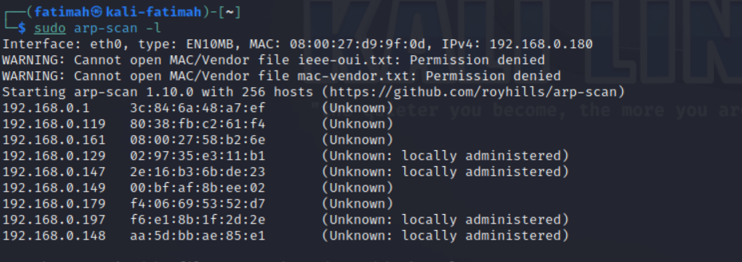Here, the device is able to see two other devices address.

Figure 3 - Other Devices Address

* This command shows the Ip address of the machine

Figure 4 - Ip Address of The Kali Machine

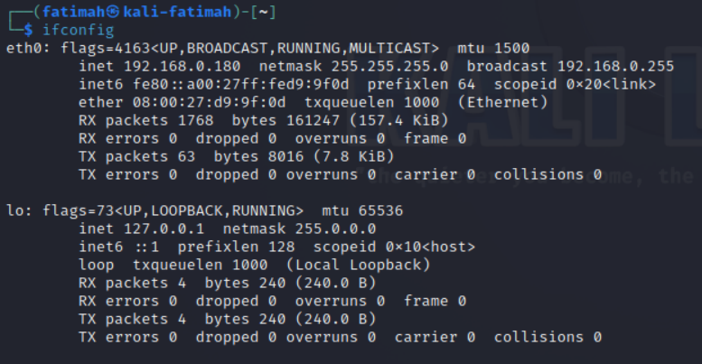

* 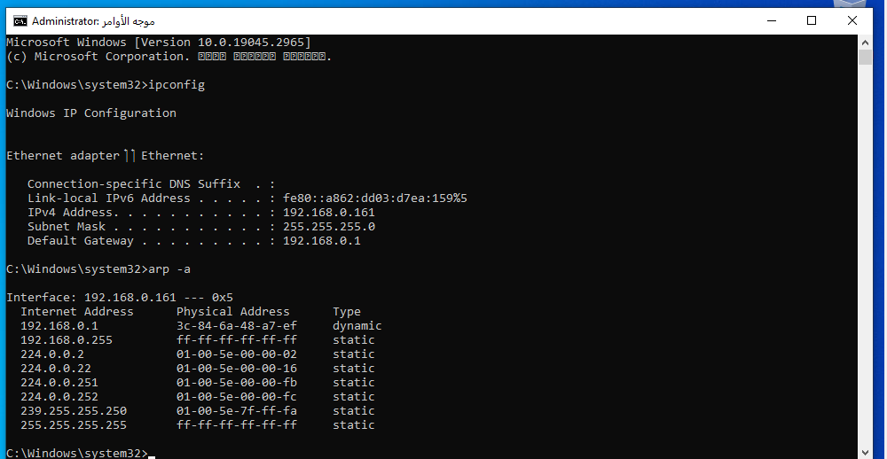In windows machine in CMD we use the commend ipconfig and ARP -a to show the IP and MAC address of the machine and what machines it can see.

Figure 5 - Windows Machine Ip Address

* We will use (Ettercap tool) to perform ARP spoofing, but first we have to make several commands in the terminal.
* Enabling the forwarding by editing the sysctl.conf file by using the below commend: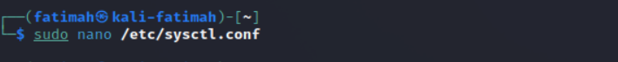

Figure 6 - Editing sysctl.conf File

* We choose the ethernet port to perform the capturing.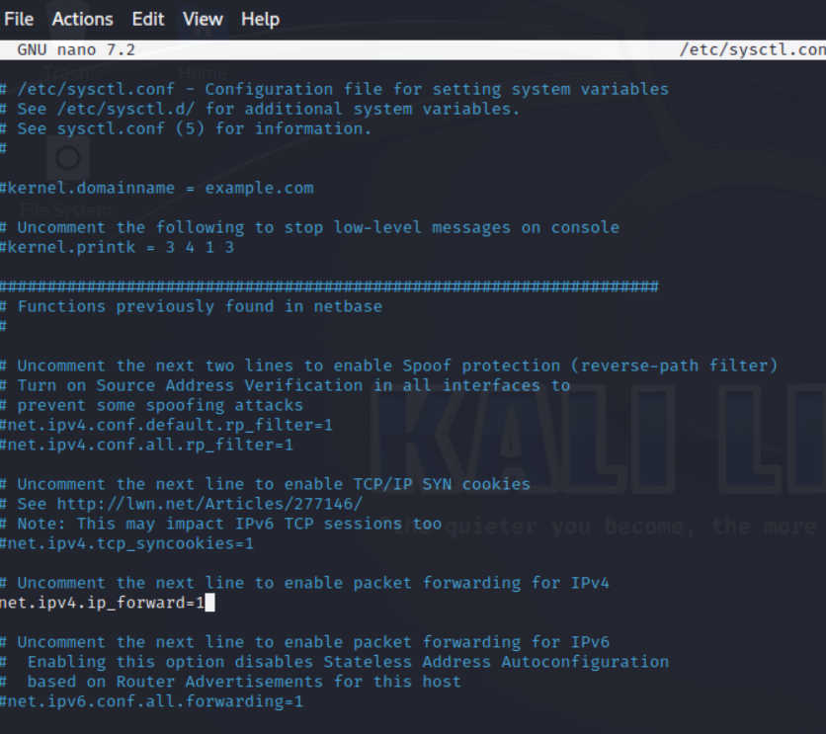

Figure 7- Modify the Code

* We will open Wireshark and Ettercap at the same time.
* Wireshark will capture the traffic for any suspicious behavior.

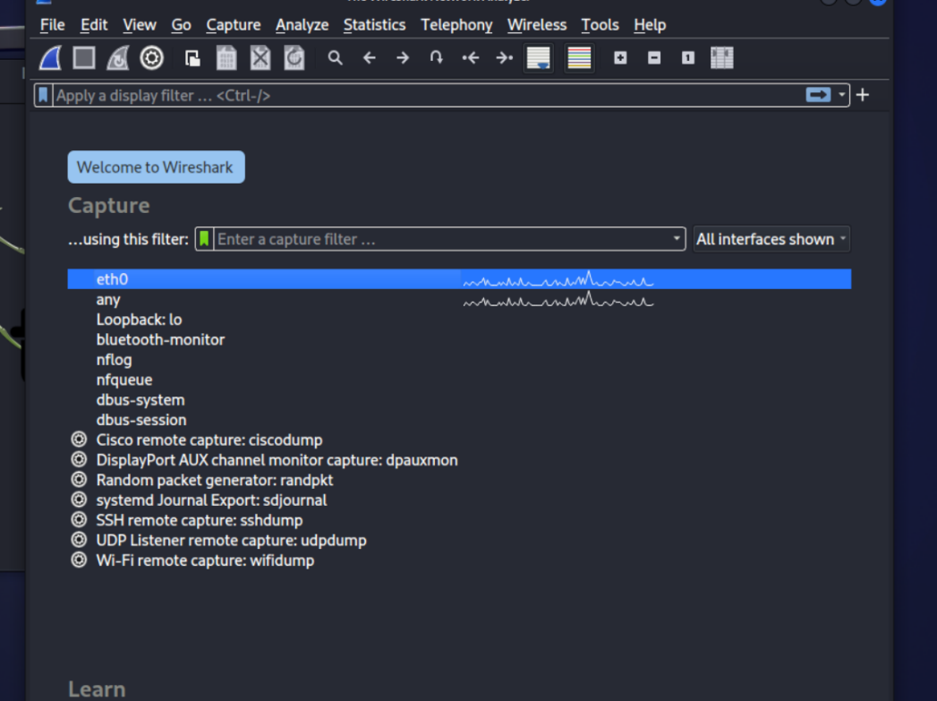

Figure 8 - Wireshark Interface

* We will choose the port that we are going to attack.

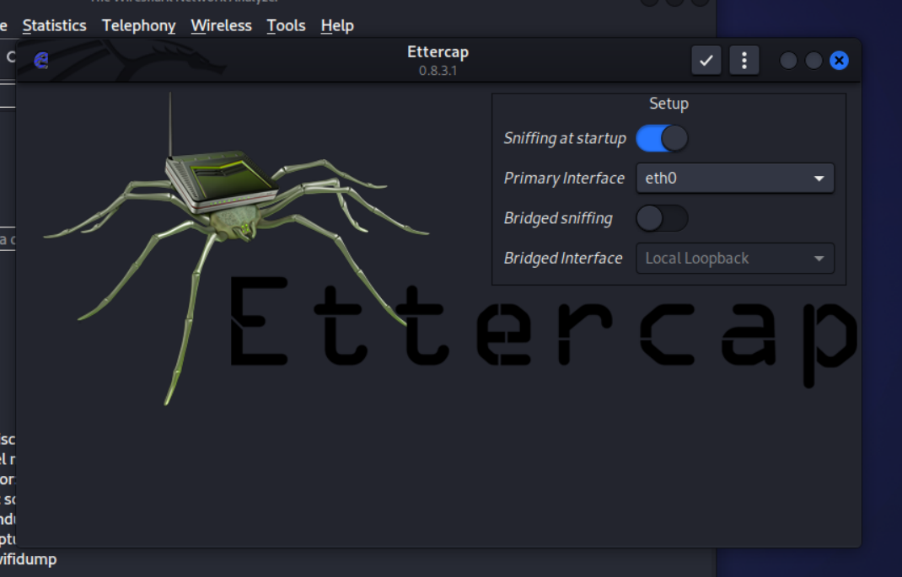

Figure 9 - Ettercap Interface

* 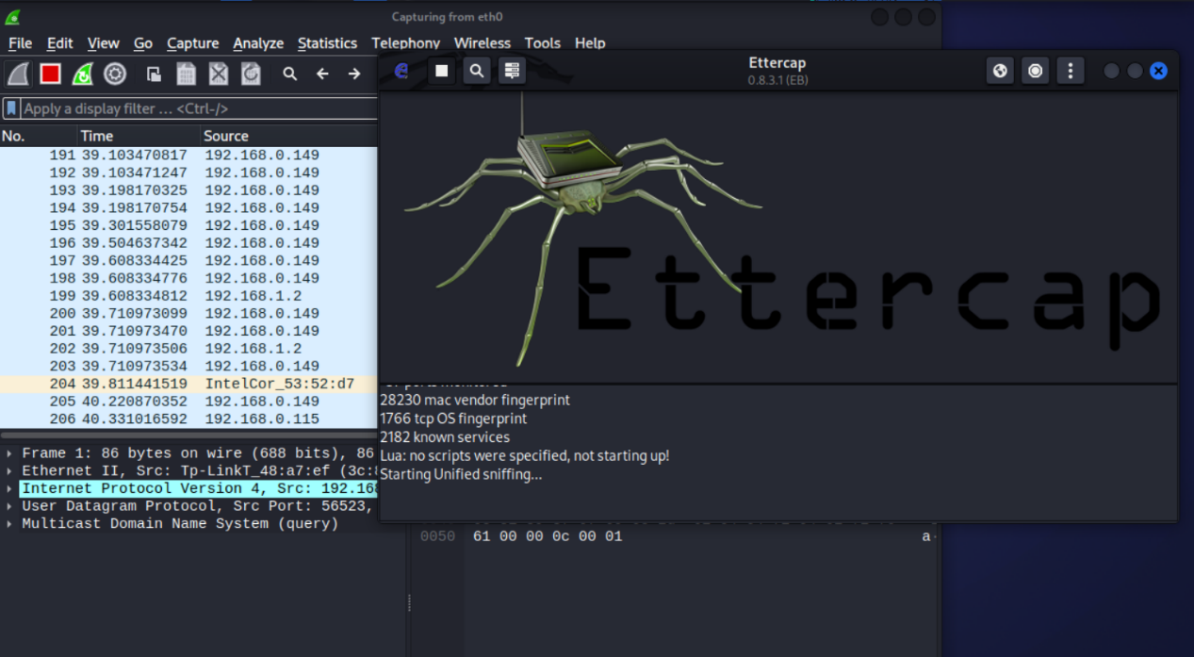We started the wire shark and Ettercap to launch the attack.

Figure 10 - Launching Wireshark and Ettercap

* We choose the first victim (windows), after we choose the second victim (windows default).

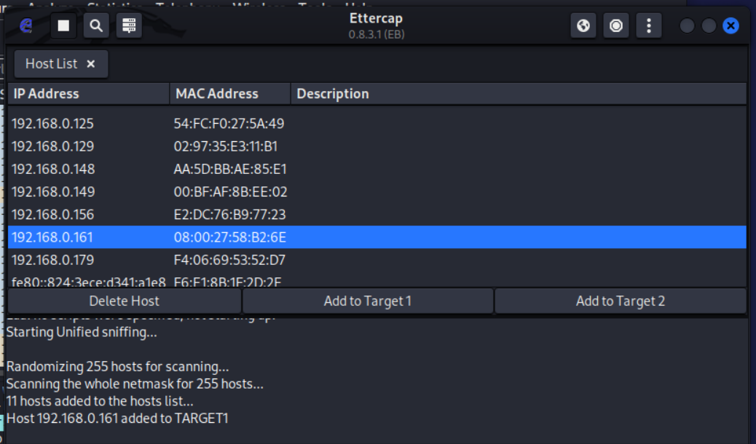

Figure 11 - Choosing the 1st Victims

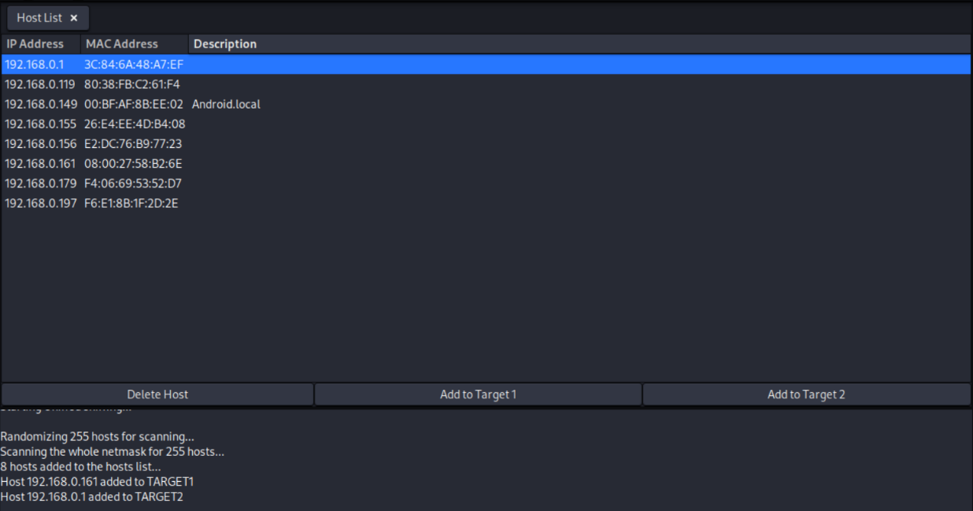

Figure 12 - Choosing the 2nd Victim

* Creating Man-In-the-Middle attack and choose the ARP spoofing type from the list.

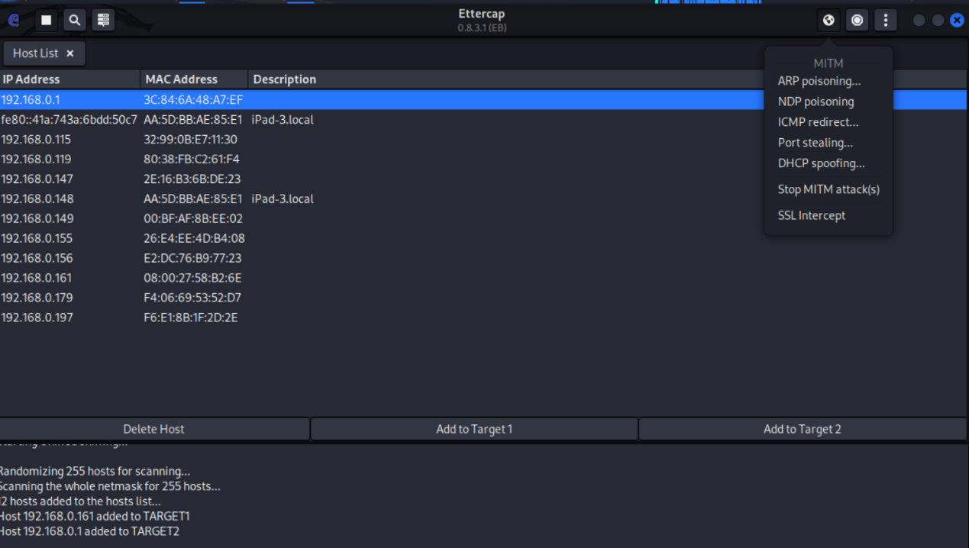

Figure 13 - Creating Man-in-the-middle Attack

* 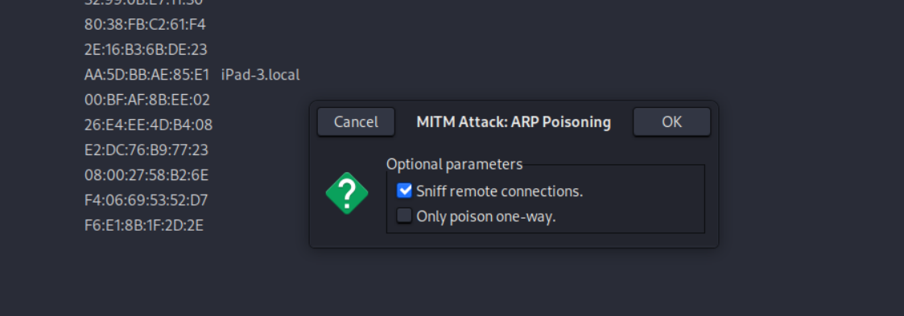We will choose the default values

Figure 14 - ARP poisoning Window

* 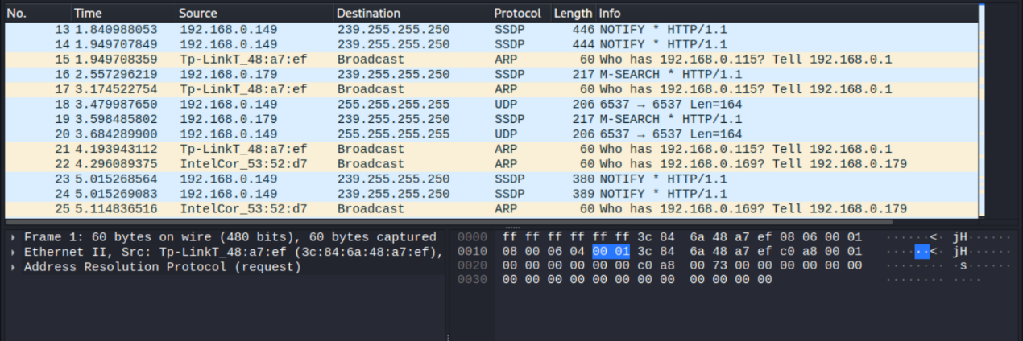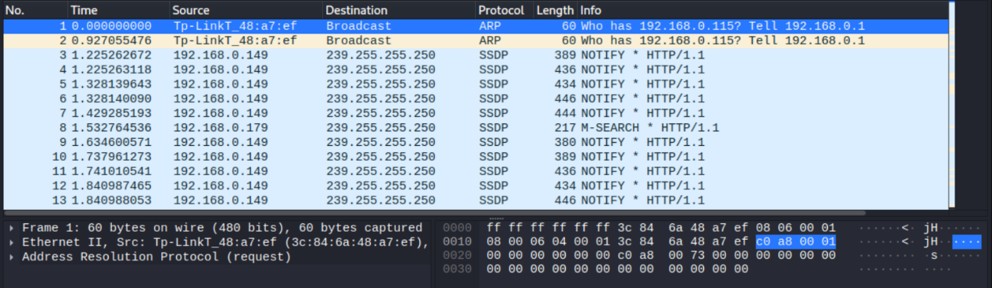Wireshark started to capture traffics coming from ARP packets

Figure 15 - ARP Traffic from Wireshark - a

Figure 16 - ARP Traffic from Wireshark - b

* To make sure that the attack successfully implemented, we will go to the windows machine and see the mac address for the default gateway (the last four bit is a7-ef for 192.168.0.61)

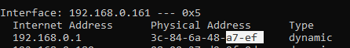

Figure 17 - Default Gateway Mac Address Before ARP Spoofing

* After ARP spoofing it changed to 9f-0d in the last four bit of the kali machine

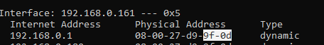

Figure 18 - - Default Gateway Mac Address After ARP Spoofing

* 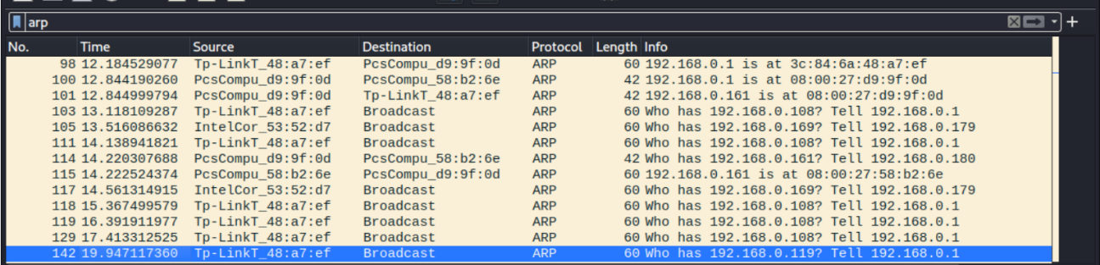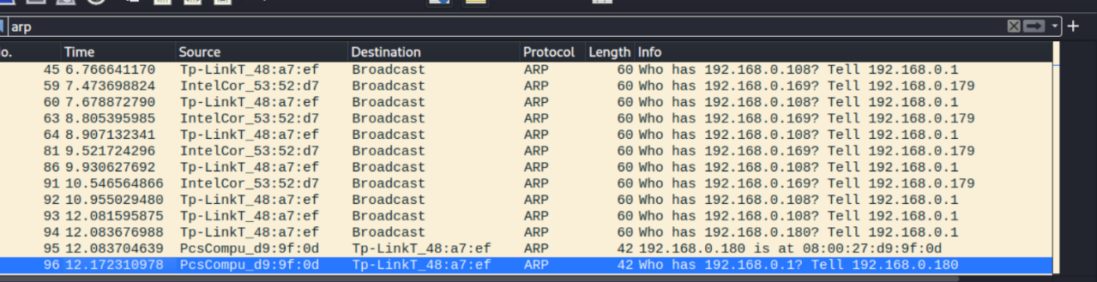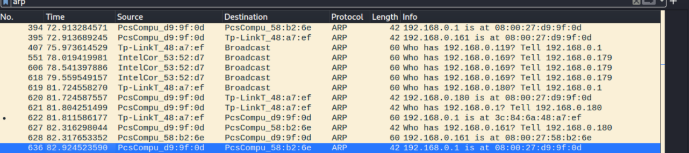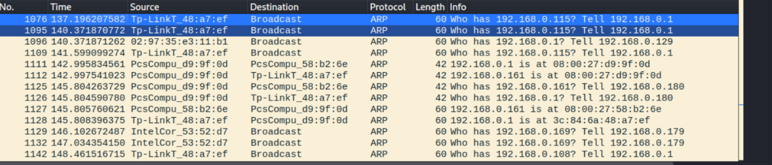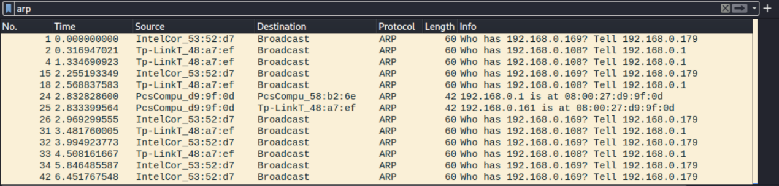ARP packets from Wireshark that had been attacked

Figure 19 - ARP Packets in Wireshark

* We will analyze packet 111

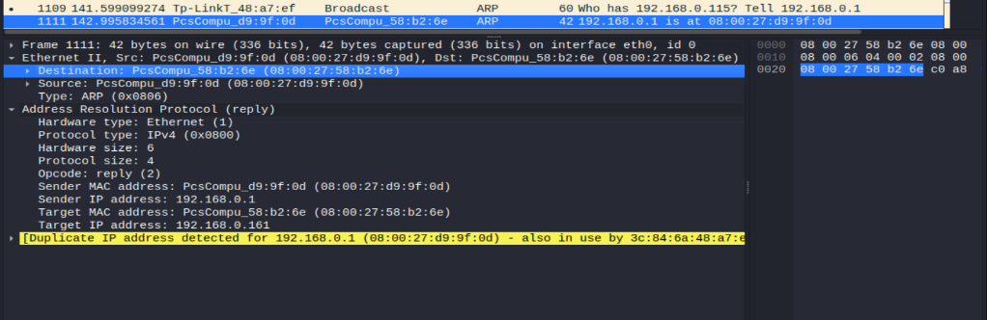

Figure 20 - Choosing a Packet to Analyze

* 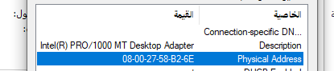We have to see the destination packet IP address which is identical to windows mac address

Figure 21 - Windows Mac Address

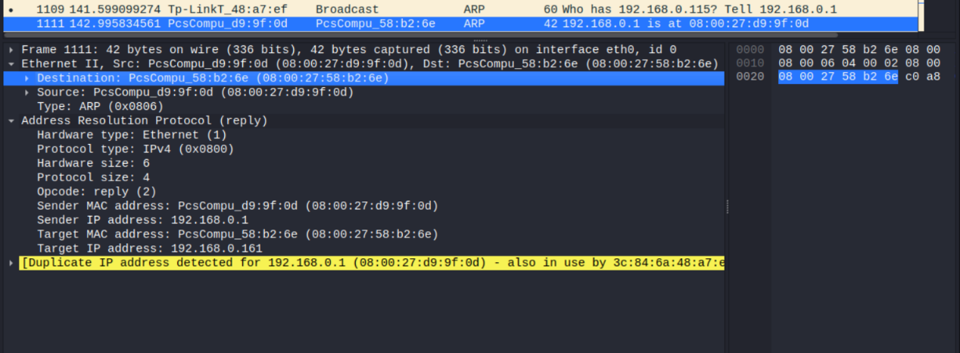

Figure 22- Destination Packet Address

* We have to see the source packet IP address which is identical to windows MAC address



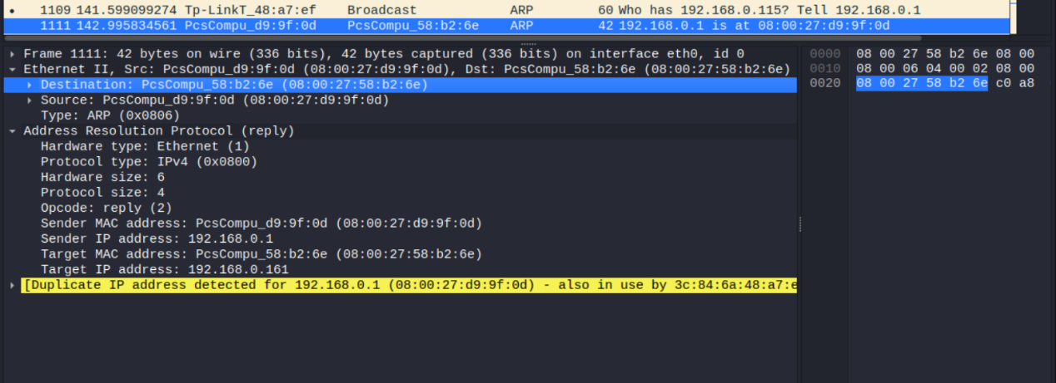

Figure 23- Kali Mac Address

Figure 24 - Source Packet Address

* 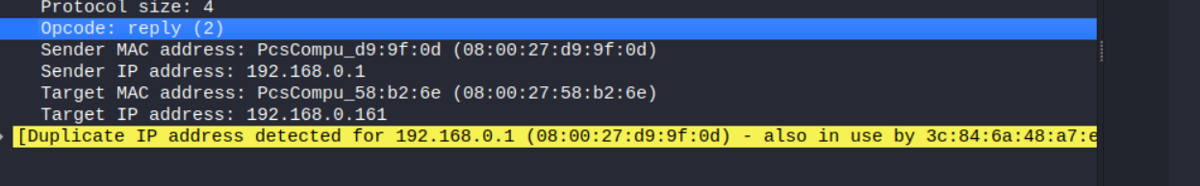The line highlighted with blue color means that I am giving the windows machine ARP response that it never asked for and did not ask from the gateway

Figure 25 - Operation Code

* 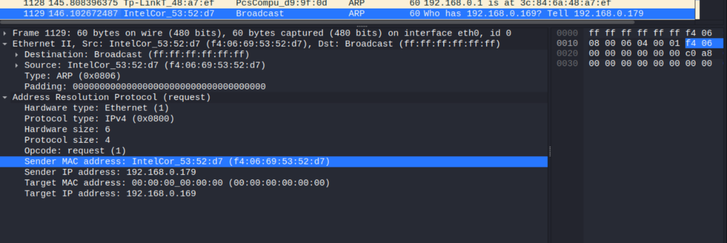Information about the packets, sender, and receive.

Figure 26 - Packet Information - a

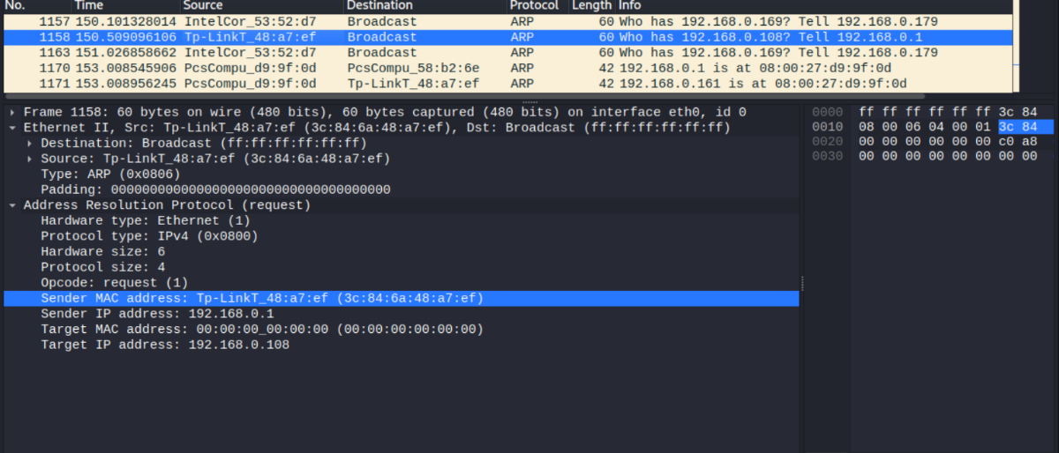

Figure 27 - Packet Information - b

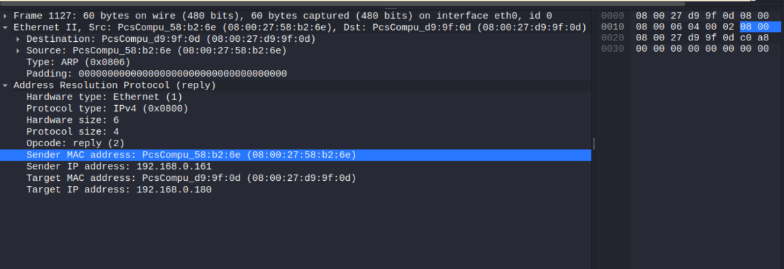

Figure 28 - Packet Information - d

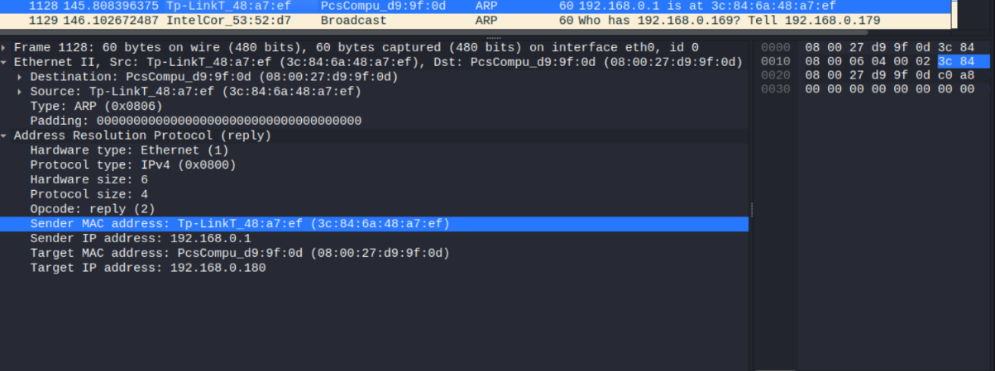

Figure 29 - Packet Information - c

* 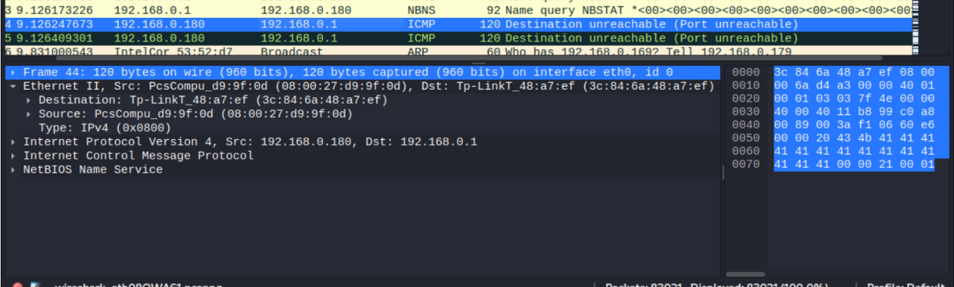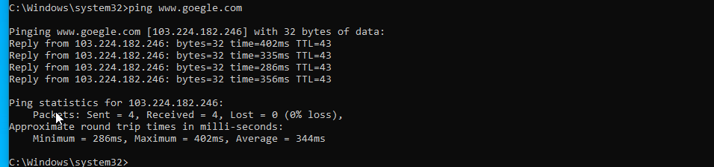Here, in order to make sure that it was done correctly, that our work is fair, we make a ping from Windows, we notice here that it picked it up, and the source is Man in the Middle.

Figure 30 - Source Address of Man-in-the middle

Figure 31 – Testing with Ping

# Summary of conclusion reached

A number of significant conclusions have been reached about the ARP spoofing attack through our forensic investigation and research. The attacker was able to alter ARP tables and eavesdrop on network traffic since the attack was launched from a compromised device. Both network security and user privacy were significantly impacted by this. A multi-layered strategy, comprising network monitoring, ARP traffic analysis, and secure network configurations, is needed to identify and stop ARP spoofing. Organizations may improve their defenses against ARP spoofing and protect their networks from unauthorized access and data breaches by understanding these conclusions.

## 3.1 Expert opinion regarding findings

The investigation's conclusions show that the ARP plagiarism attack on SADAIA's network had a significant impact. Employee XX2 was found to be the source of the attack, raising questions about internal threats. The attack cost SADAIA's money and disrupted operations, making it difficult for it to do business effectively. Due to its obligations to the Communications Commission, this event also jeopardizes SADAIA's reputation and legal standing. It is recommended that SADAIA's strengthen network security measures, provide cybersecurity awareness training to employees, and think about the best course of action to take in response to co-worker engagement in order to address these challenges. The organization's network will need to be protected from unauthorized access and similar attacks in the future by implementing incident response methods and surveillance systems.

# Password Cracking Attack

# Introduction

Password cracking is a type of attack that involves making repeated guesses at or attempts to decode passwords in order to obtain unauthorized access to a system or an account. This report seeks to give readers a general understanding of password cracking attacks, their effects, and possible defenses. It examines the techniques employed in password cracking attempts, the influence they have on system security, and successful countermeasures. Organizations and individuals can reduce the risks associated with these assaults and protect their sensitive information by comprehending the nature of password cracking and implementing strong password rules.

## Summary of case and tasking

Status and task summary Between 1-6-2023 and 15-6-2023, some passwords used by SDAIA employees were broken and many of the passwords used were leaked as it was discovered that employees use weak passwords and are applied to all their accounts in SDAIA

# Forensic examination

The analysis of password hashes, password recovery tools, and brute-force attacks are just a few of the forensic investigation methods used in password cracking attacks that will be covered in the report. It seeks to expose the strategies and equipment employed by attackers to break passwords and obtain unauthorized access to accounts or systems.

## 2.1 Tools

For our security analyses, we use John the Ripper, an efficient password cracking tool. We are able to extensively assess the security of passwords in a controlled setting due to its extensive feature set and support for several password hash formats. We can locate weak passwords and discover potential security holes in the system by using strategies like dictionary attacks, brute force assaults, and hybrid attacks. We have the tools required to successfully crack passwords and improve overall security thanks to its adjustable settings, adaptable design, and broad plugin support. Our arsenal would not be complete without John the Ripper, which we use to conduct thorough security analyses and ensure strong password security.

## 2.2 Chain of custody

One of the employees tried to defraud one of the department managers and use his computer as a result, he was able to access the files of the computer and break the files of the passwords.

*All these scenarios have been simulated and the attacker character has been worked on

## 2.3 Method of process

* Creating a file which will contain the hash value of the password(we use the MD5 hashs ).

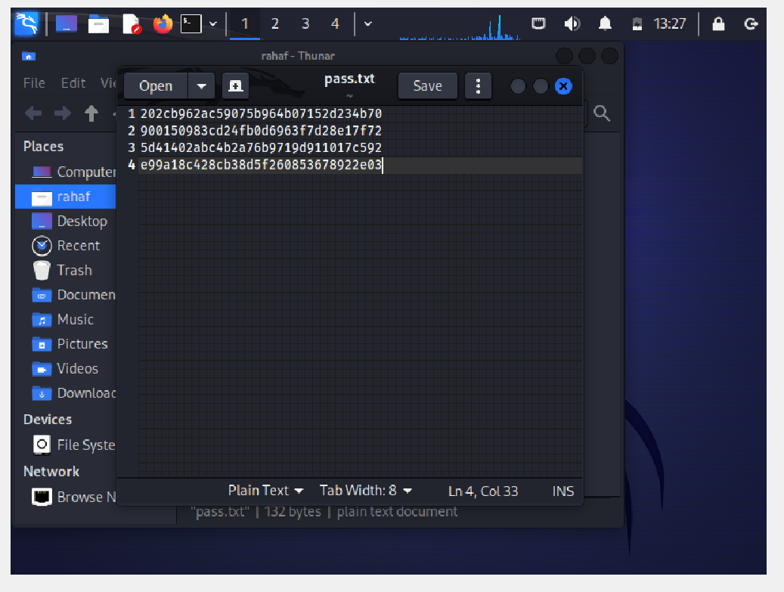

Figure 32 - Creating passwords file

* This command is used for John’s single cracking

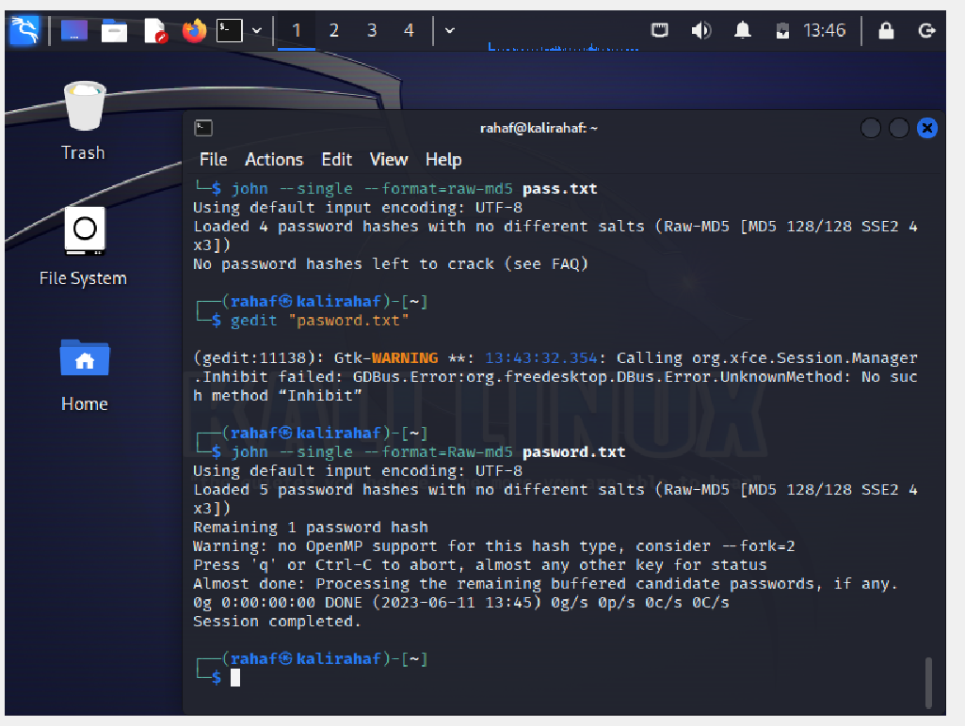

Figure 33 - Crack Mod

* John will load the passwords file, and try a few algorithms to crack them.

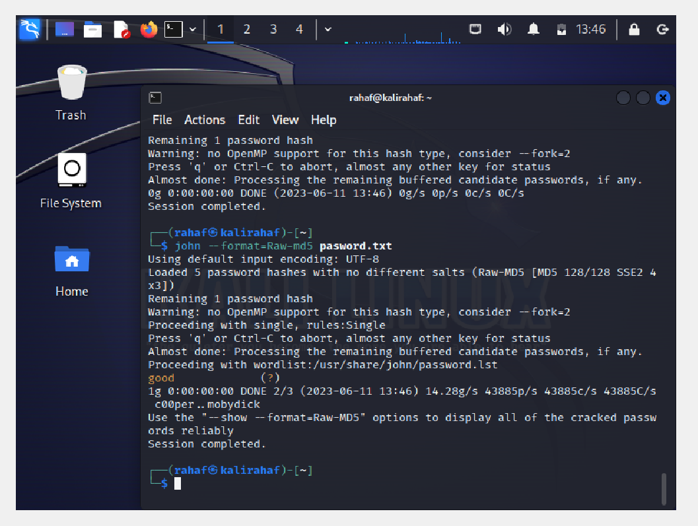

Figure 34 - Load Password File

* This command shows cracked passwords in John.

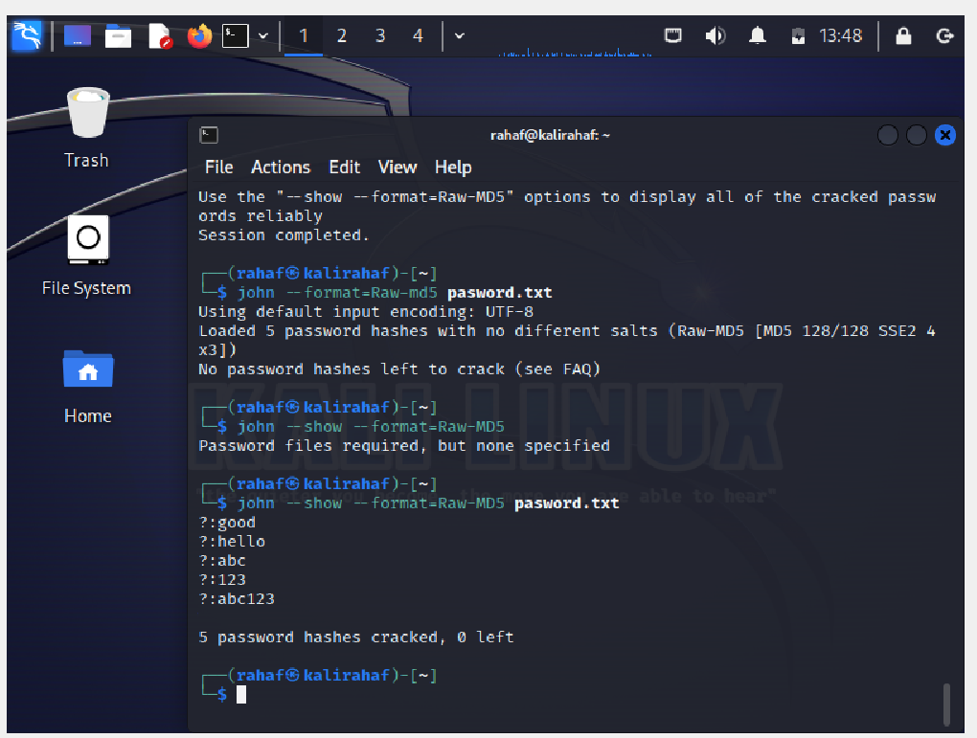

Figure 35 - Show Cracked Password

# Summary of conclusion reached

The investigation's findings support the assertion that password cracking creates serious security dangers. Weak passwords are a common weakness, as shown by the evaluation of password hashes, the use of password cracking programs like John the Ripper, and the analysis of the available data. The results highlight the value of implementing strong password rules, such as multi-factor authentication, complicated and frequently updated passwords, and user education on password security. To reduce the danger of unauthorized access and safeguard sensitive data, it is essential to strengthen password security procedures. Organizations can improve their overall security posture and lessen the potential effects of password cracking attacks by putting these steps into place.

## 3.1 Expert opinion regarding findings

The investigation's conclusions show that strong passwords should be used that are difficult for algorithms to break, as humiliation causes several security breaches within SDAIA, resulting in huge financial losses and loss of SDAIA reputation.

# Social Engineering Tool Kit

# Introduction

The Social Engineering Toolkit (SET) is a suite of custom tools that focuses solely on attacking the human element of pen testing. SET can be used to phish a website along with a Metasploit module or Java-driven attacks; send phish mails, and file format bugs. It is designed for social engineering and has multiple attack vectors including email, SMS, USB, and more.

SET is an open-source penetration testing framework designed for social engineering. It has both GUI and console-based versions. It was specifically designed to perform advanced attacks against the human element and has quickly become a standard tool in a penetration tester's arsenal.

## Summary of case and tasking

Status and task summary Between 1-6-2023 and 16-6-2023, many emails were sent to SDAIA employees to update passwords for registered accounts belonging to Google (Gmail).

# Forensic examination

There are now many attacks and methods used by fraudsters, and one of the easiest and simplest ways is to use false messages by sending them using e-mail, where they can access the account and be able to manage it as they want.

## 2.1 Tools

As for our security analytics, where several employees in SDAIA opened that link and entered their account data, in the meantime, the hacker was able to take user data and get an opportunity to sell their data and control the employees' accounts, which led to the leakage of many sensitive information that the e-mail was used to transfer among employees.

## 2.2 Chain of custody

After the attacker was able to send fake messages to employees and take their information by the employees click on the link attached in the email and take their information.

*All these scenarios have been simulated and the attacker character has been worked on

## 2.3 Method of process

SET : have a lot of type and methods one of this type is credential Harvester attack method for do this :

* We should choose website that the user visited and login many time
* Tool will save the info about this website on the server

When the employee enters the site, the site page will appear to him, where the victim will think that this is not the original or official site of Google (Gmail), where he will start entering his data and renewing it. Meanwhile, the attacker takes a copy of this data that the employee entered.

* We will start by logging in to the root using the terminal to specify the path that will be used using the following command:

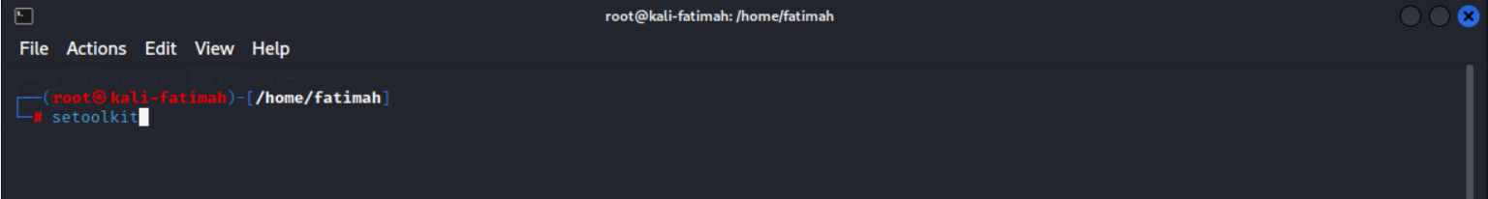

Figure 36: Root in Terminal

* After that, this screen will appear to display information about the tool used, where it must be stopped according to the terms and conditions, and then it is possible to choose the type of attack required by choosing the number corresponding to each service.

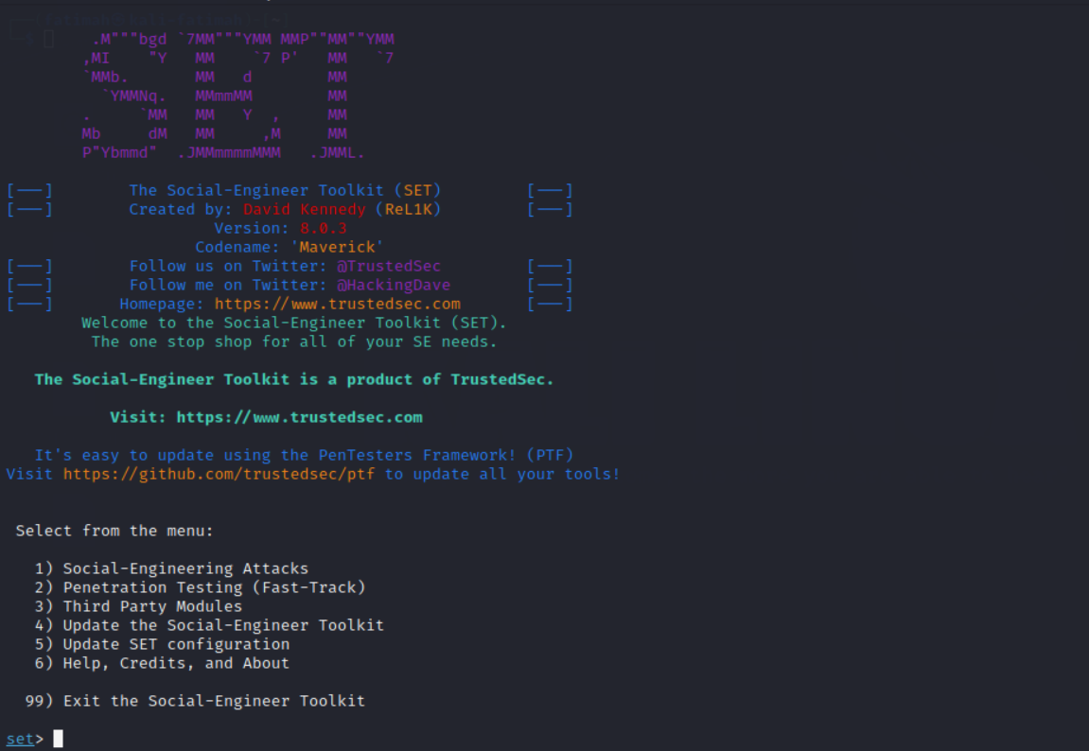

Figure 37: Interface of SET

* In this plan, No. 1 will be chosen for the application of social engineering, and after that a list of many types of attack will appear to us, but we focus in this report on the attack using the web, which is No. 2.

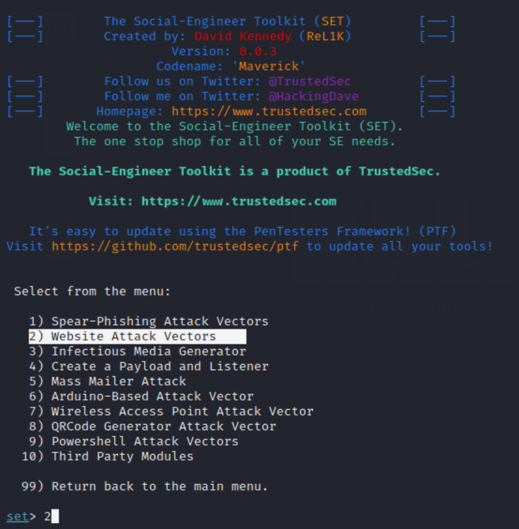

Figure 38: Interface of the Web attack

* After that, a list will appear for us to determine the method that will be applied, and a simple explanation for each type, where we will choose number 3, where we want to collect the data of the 1 employee who open the link and start completing their data.

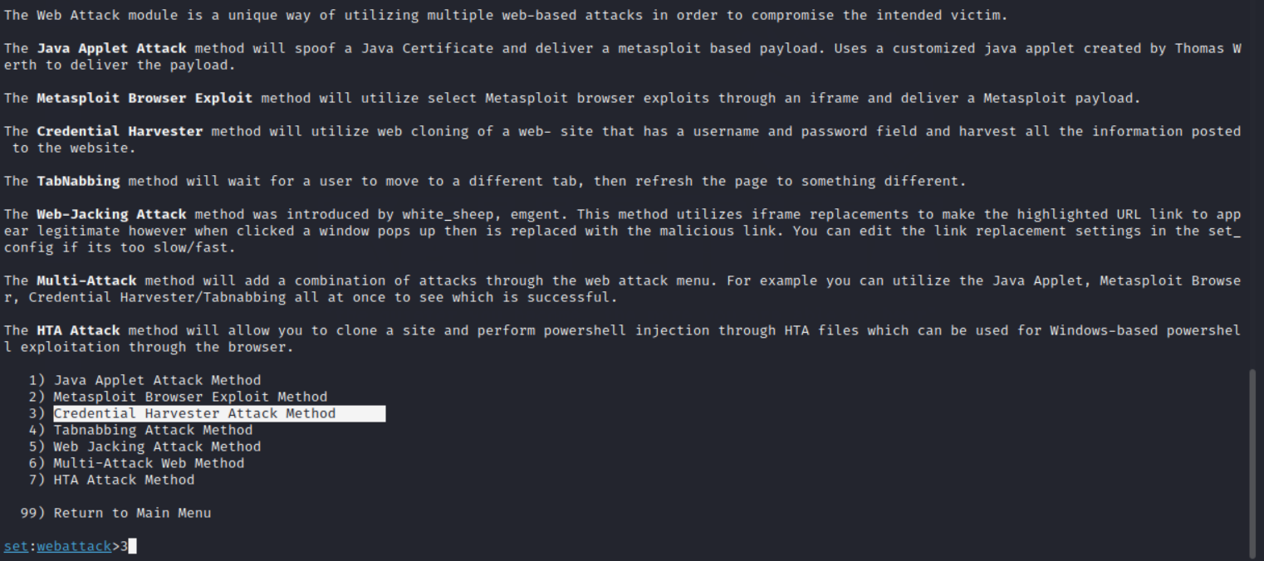

Figure 39: Cont...

* When you see a list of phishing website creations methods, of course, there is an explanation of the method that we choose in the image, and we choose number 1. Now, this method enables the hacker to extract a set of predefined websites that we can use to attack

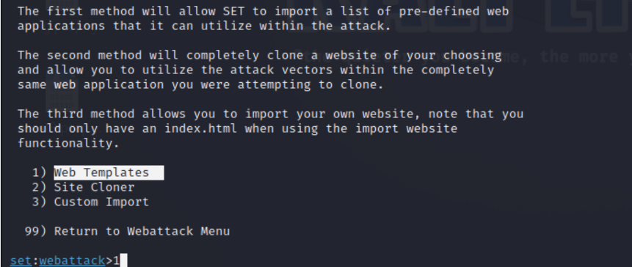

Figure 40: Import web template

* Here it will ask me to put the IP address of the hacker or the back gate, which is Kali

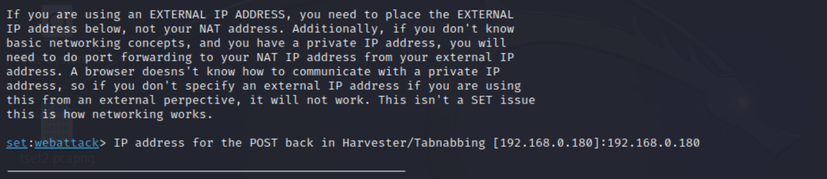

Figure 41: Gateway(kali)

* Then he will ask me for a template to choose from the list here. I will choose that the victim will be from Google because I am doing fishing by sending an email with a link to confirm the password

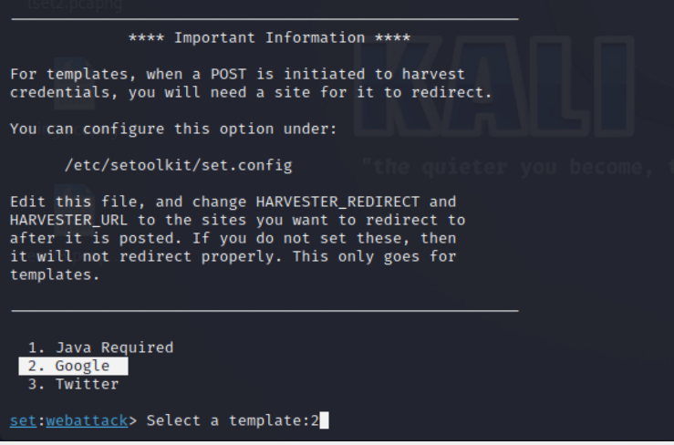

Figure 42: Google template

* Then I will go to create a new email message in which I choose the victim and set up the link. This picture shows that I chose the victim and wrote an address for her to change the password so that it is safe

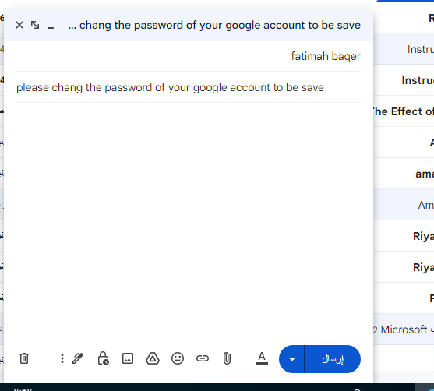

Figure 43: creation of the Email

* After that, I just opened the link, put the web address, is the right to study Kali, and gave it an address

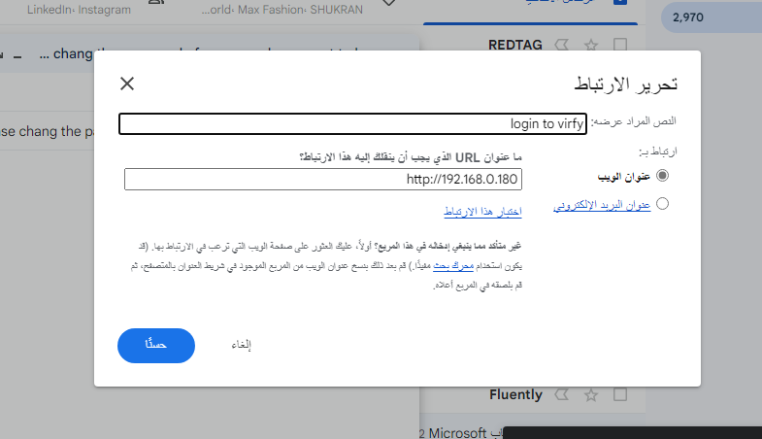

Figure 44: Link the email

* Then I sent him this picture showing that he had reached the victim. When the victim clicks on the link, he will enter him on a page where he enters the username and password, and Kali picks them up.

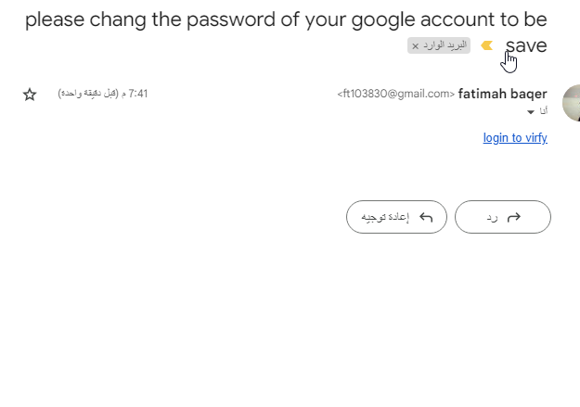

Figure 45:Email that received

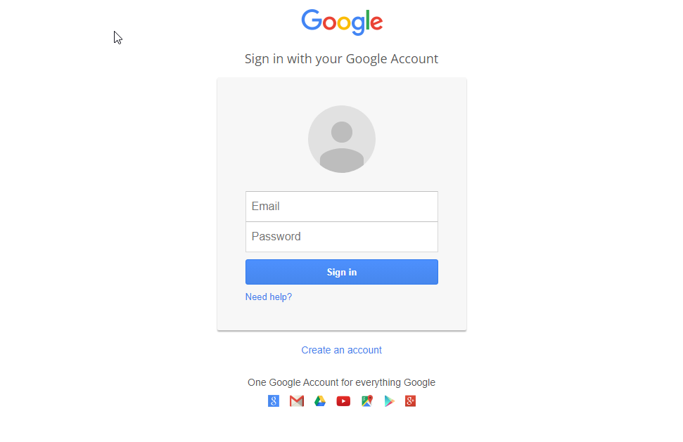

Figure 46: Phishing the information by using the Google form Sign in

* At the same time when we open the page for taking information, Kali detects that someone opened the site here and explained that the device that has the address of this one entered the link

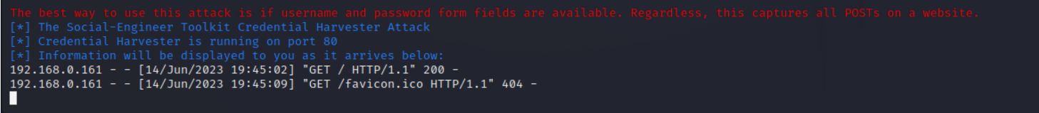

Figure 47:Kali gets the information

* Kali picked up the username and password you entered

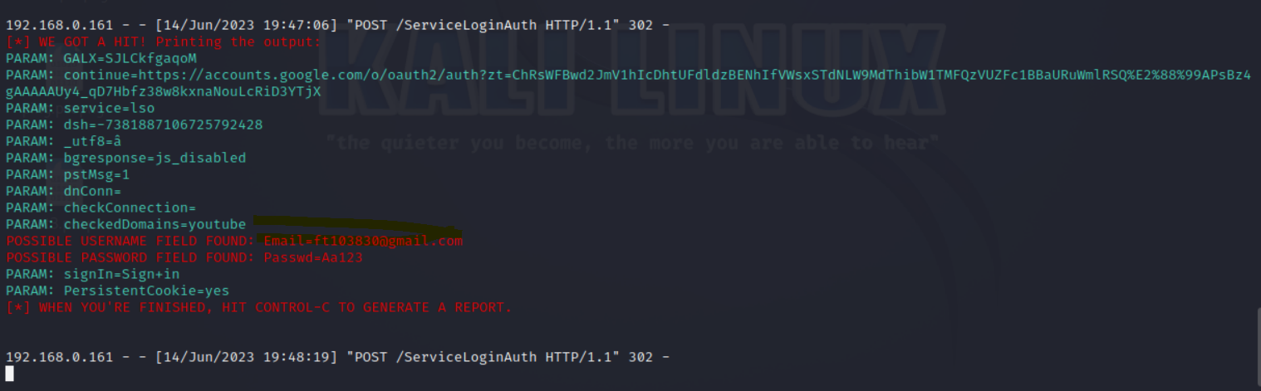

Figure 48:Show the information

* But this type of attack will not work outside the scope of the network in which it happened. For example, if I open the normal Google, which is outside the disgraceful, and put the study on the right of Kali, of course, here it is turned on for us, but let us know that it is not safe. Or disgraceful see it as an unsafe site

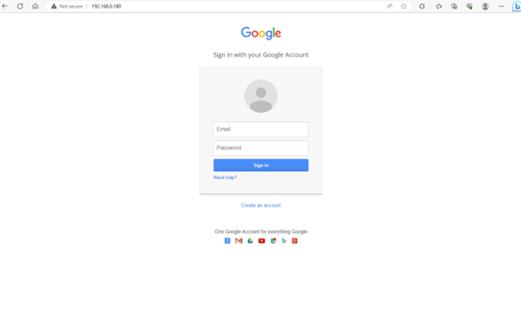

Figure 49: show it is not secure

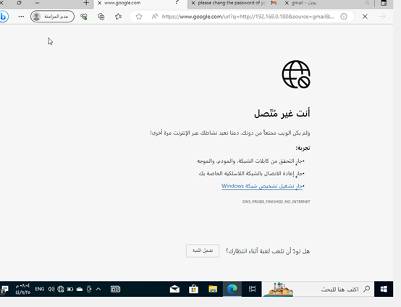

Figure 50:cont...

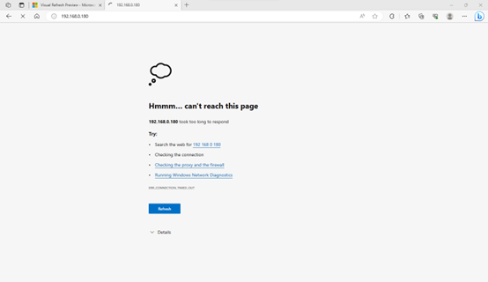

Figure 51:cont...

# Summary of conclusion reached

The results of the investigation support the assertion that employees should pay attention to the email sent to them as they are an entry point to SDAIA network resources and that the address sent from the email should be verified.

## 3.1 Expert opinion regarding findings

The investigation findings show that employees should be assured of verifying the messages sent to them and from what address the message was sent to avoid leakage of their data outside the SDAIA network.

# References

|  |  |
| --- | --- |
| [1] | PROFESSOR.127.0.0.1. (2022, June 26). *2.USING SETOOLKIT FOR PHISHING ATTACKS* [Video]. YouTube. <https://www.youtube.com/watch?v=2zLmdXQitF4> |
| [2] | Shivanandhan, M. (2022). How to Crack Passwords using John The Ripper – Pentesting Tutorial. *freeCodeCamp.org*. <https://www.freecodecamp.org/news/crack-passwords-using-john-the-ripper-pentesting-tutorial/> |
| [3] | Pat. (n.d.). *Getting Started With John The Ripper On Kali Linux – InfosecScout*. <https://infosecscout.com/john-the-ripper-on-kali-linux/> |
| [4] | *MD5 Hash Generator*. (n.d.). <https://www.md5hashgenerator.com/> |
| [5] | Vojtko, M. (2023, March 20). *Everything You Need to Know About ARP Spoofing*. Hashed Out by the SSL StoreTM. <https://www.thesslstore.com/blog/everything-you-need-to-know-about-arp-spoofing/> |
| [6] | Chris Greer. (2021, December 9). *How ARP Poisoning Works // Man-in-the-Middle* [Video]. YouTube. <https://www.youtube.com/watch?v=cVTUeEoJgEg> |